Exploring the Japanese Restaurants of New York CIty, USA – Report

Business Problem

As of the 2000 Census, over half of the 37,279 people of Japanese ancestry in the state of New York lived in New York city. With this comes an abundance of Japanese restaurants spread across the many boroughs and neighbourhoods of the city. However, there is a lack of a central source of information for anyone interested in gaining a greater insight into the distribution and features (ratings) of these restaurants.

Who Would Be Interested:

* New Yorkers and tourists who want to find the best neighbourhood/restaurant for Japanese food.
* Those who are looking to move to New York and are particularly fond of Japanese food.
* Investors and restaurateurs looking to open a new Japanese restaurant.
* Owners of existing restaurants looking to research their competition.

Data

1. <https://cocl.us/new_york_dataset>

* Jason file containing data we need to explore the boroughs and neighbourhoods of New York city.

1. Foursquare API

* We will make calls on the Foursquare API to retrieve data on the Japanese restaurants of New York City.

Results

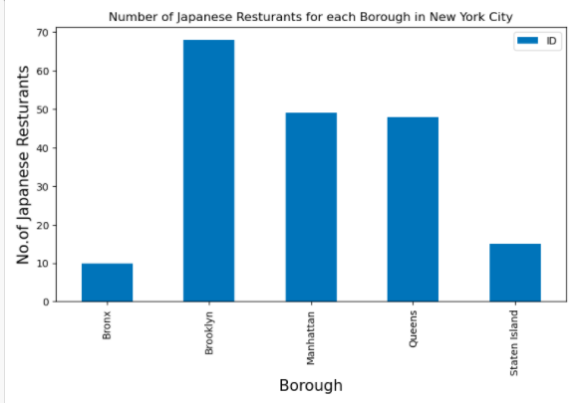

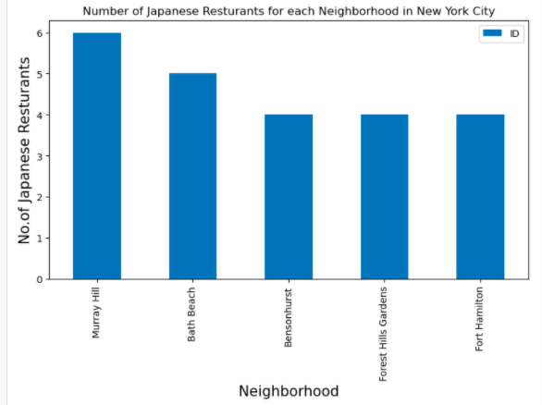

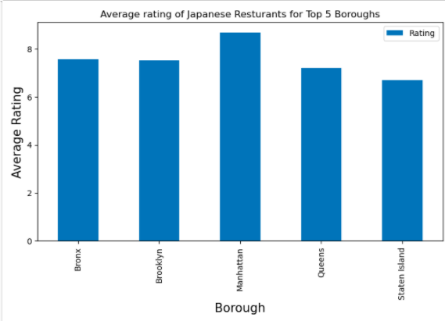

Conclusion

New York City has an abundance of great Japanese restaurants, purely in terms of numbers, the borough of Brooklyn holds the most Japanese restaurants. However in terms of average rating, Manhattan scores highest out of all the boroughs.